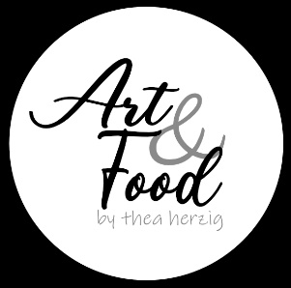
Pastellisten aus aller Welt

Floral
Lyn Diefenbach http://ldief.com/

Landschaften
Zaria Forman https://www.zariaforman.com/

Richard McKinley http://mckinleystudio.com/

Liz Haywood-Sullivan https://www.lizhaywoodsullivan.com/

Astrid Volquardsen https://www.volquardsen.art/

Jill Stefani Wagner https://www.jillwagnerart.com/
Menschen / Portrait
Alain Picard https://www.picardstudio.com/

Jill Stefani Wagner https://www.jillwagnerart.com/

Svetlana Cameron https://www.svetlanacameron.com/

Stillleben
Grudrun Sallaberger-Plakolb https://www.artgudrunsp.com/

Michael Freeman https://www.michaelfreemanartist.com/

Dimonique Houard https://www.dominiquehouard.com/

Olga Abramova https://olgaabramova.art/en/

Tiere
Natalia Leonova https://www.instagram.com/yanatpastels/

